PRELIMINARY TASK – ARDUINO AND GIT INSTALLATION [5 MARKS]
(a) Create a GitHub account.

(b,c)Create a repository where you will work and include the files for this project.
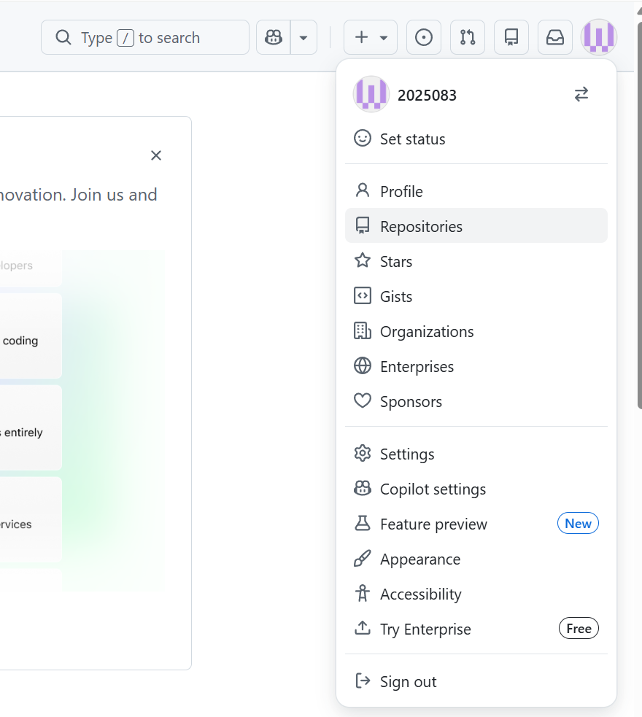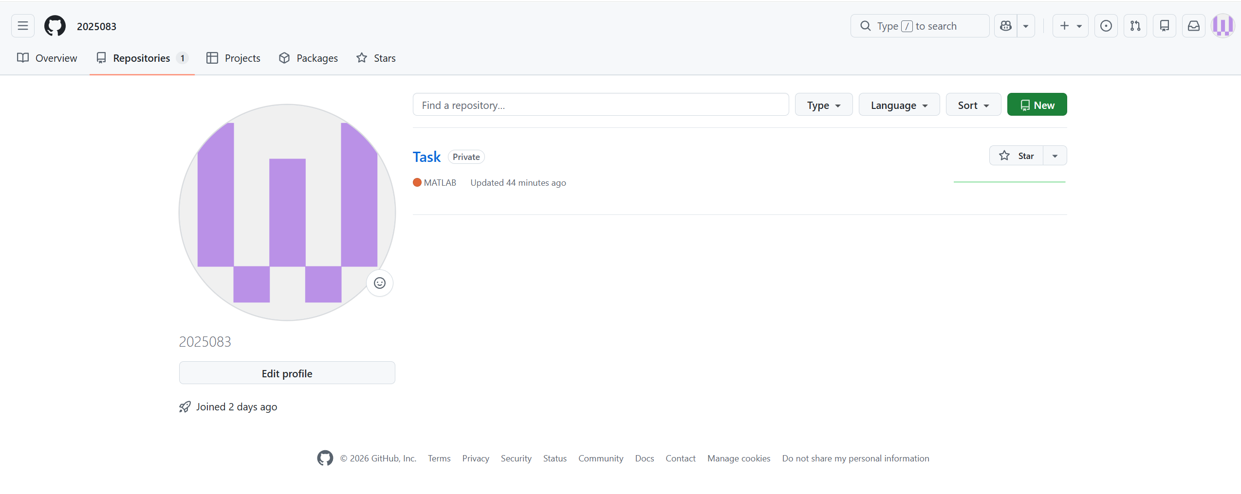
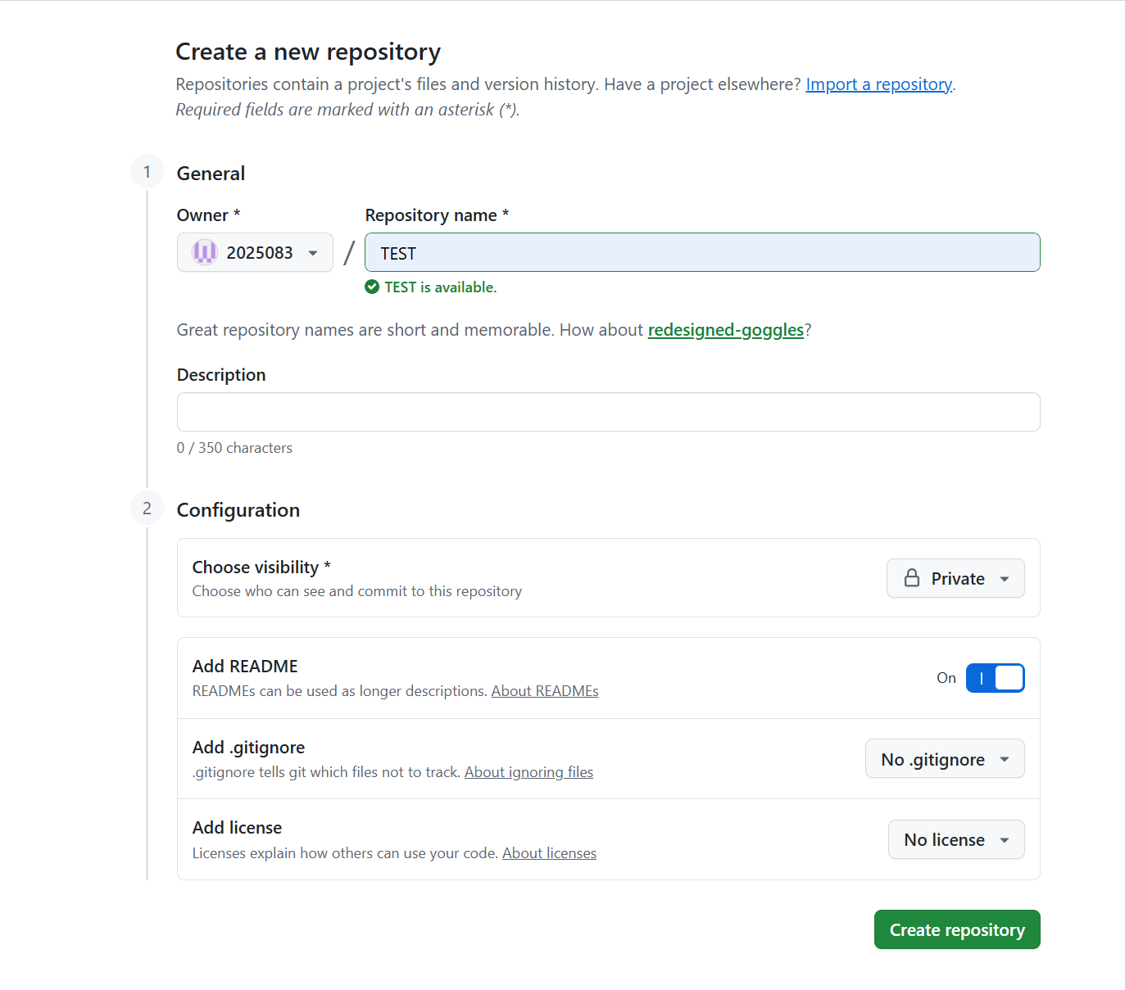
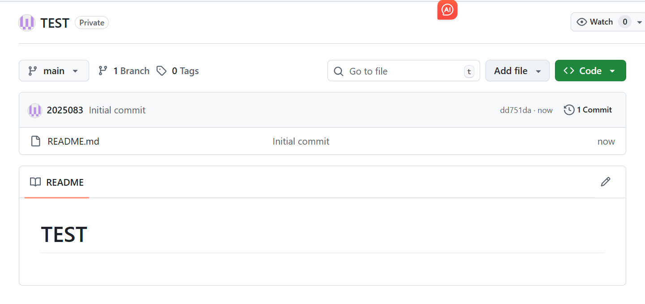
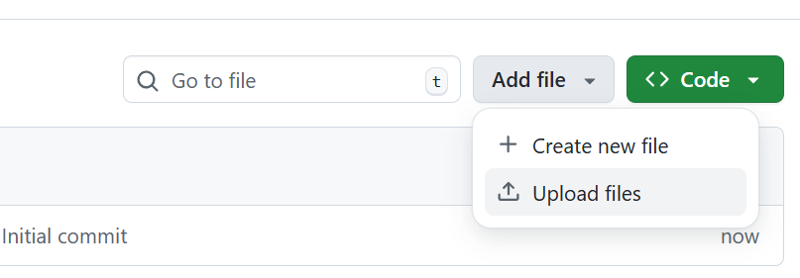
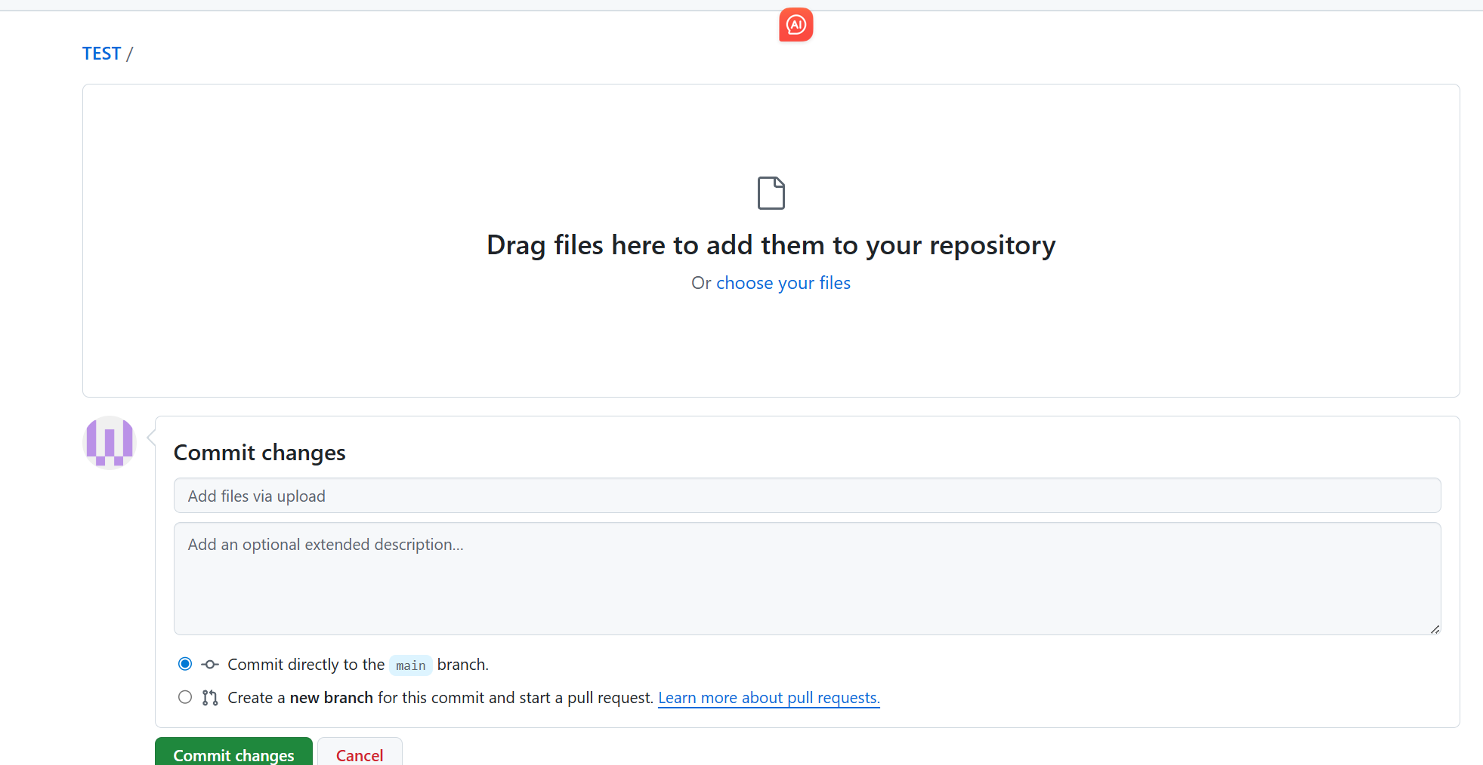
(b)
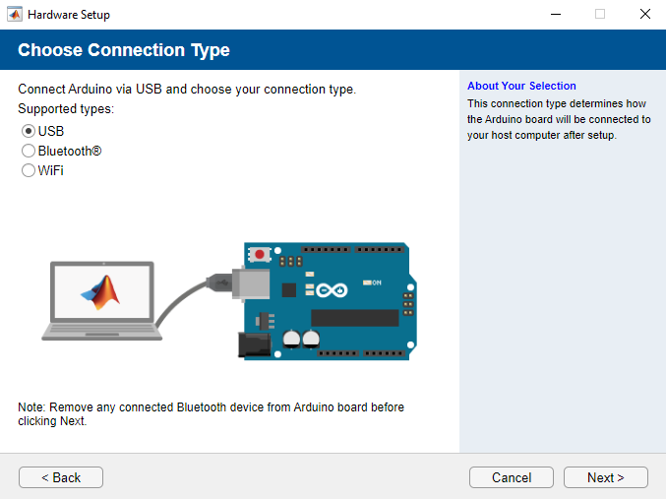
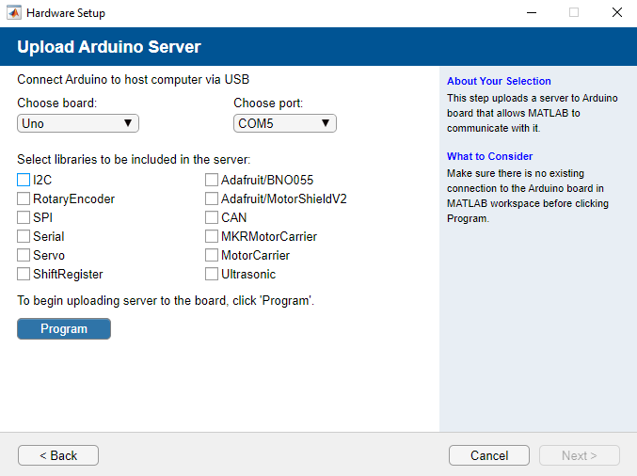
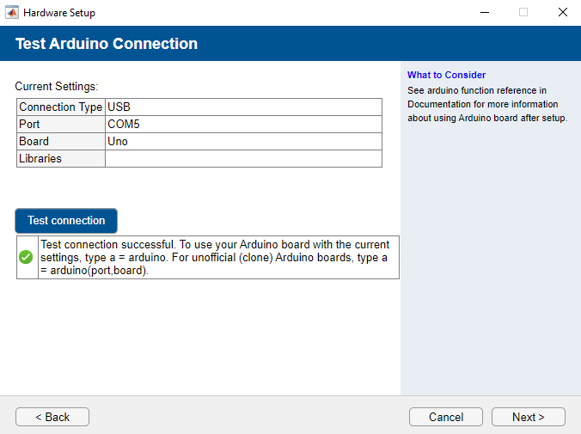
(c)
clear; clc; close all;

arduinoPort = 'COM3';
arduinoBoard = 'Uno';
try
a = arduino; % Create Arduino communication object
disp('The Arduino connection was successful!');
catch ME
error('Arduino connection failed.');
end
ledPin = 'D12'; % LED digital pin (flashing test)
blinkCount = 10;
disp(['Start flashing LED，A total of ', num2str(blinkCount), ' times.']);

for i = 1:blinkCount
writeDigitalPin(a, ledPin, 1); % Turn on LED (high level)
pause(0.5);

writeDigitalPin(a, ledPin, 0); % Turn off LED (low level)
pause(0.5);
end
clear a;
disp('The flashing is complete. The Arduino connection has been closed!');
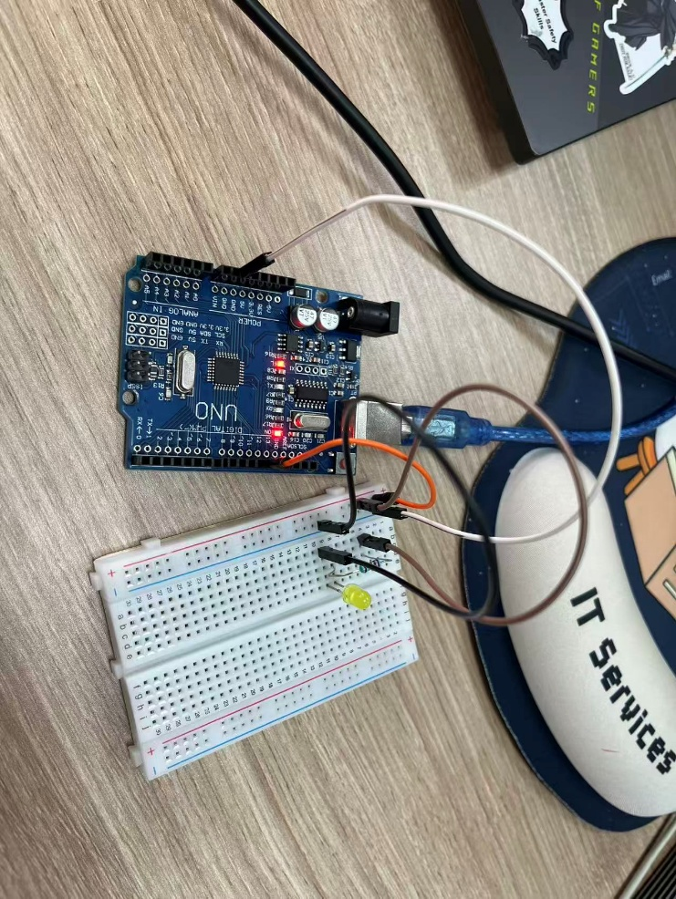

TASK 1 – READ TEMPERATURE DATA, PLOT, AND WRITE TO A LOG FILE [ 20 MARKS]
clear; clc; close all;
duration = 600;
sample_interval = 1;
sensor_pin = 'A1'; % Temperature sensor analog pin (MCP9700A)
arduino_port = 'COM3';
arduino_board = 'Uno';
V_0C = 0.4; % MCP9700A voltage at 0°C (V)
T_C = 0.01953; % MCP9700A temp coefficient (V/°C)

try
a = arduino(arduino_port, arduino_board);
disp(' The Arduino connection was successful!');
catch ME
error('Arduino connection failed.');
end

num_samples = duration / sample_interval;
time_vec = 0:sample_interval:duration-sample_interval;
temp_vec = zeros(1, num_samples);

disp([' Start collecting. ', num2str(duration/60), 'min temperature data']);
for i = 1:num_samples
V_out = readVoltage(a, sensor_pin); % Read sensor voltage
temp_vec(i) = (V_out - V_0C) / T_C; % Convert voltage to temperature
pause(sample_interval);
end
disp(' Data collection completed! ');
max_temp = max(temp_vec);
min_temp = min(temp_vec);
avg_temp = mean(temp_vec);

figure('Color','w');
plot(time_vec/60, temp_vec, 'b-o', 'LineWidth', 1.5, 'MarkerSize', 4);
xlabel('Time (minutes)', 'FontSize', 12);
ylabel('Temperature (°C)', 'FontSize', 12);
title(['Temperature vs. Time (', num2str(duration/60), ' minutes)'], 'FontSize', 14);
grid on;
saveas(gcf, 'temperature_plot.png'); % Save temperature curve to file
disp(' The temperature curve has been saved as temperature_plot.png');

current_date = datestr(now, 'dd/mm/yyyy');
location = 'Nottingham';

fprintf('Data logging initiated - %s\n', current_date);
fprintf('Location - %s\n\n', location);
max_minute = ceil(duration/60);
for minute = 0:max_minute
idx = minute * 60 + 1;
if idx > num_samples
temp_val = temp_vec(end);
else
temp_val = temp_vec(idx);
end
fprintf('Minute\t\t%d\n', minute);
fprintf('Temperature\t%.2f C\n\n', temp_val);
end
fprintf('Max temp\t%.2f C\n', max_temp);
fprintf('Min temp\t%.2f C\n', min_temp);
fprintf('Average temp\t%.2f C\n\n', avg_temp);
fprintf('Data logging terminated\n');

fid = fopen('capsule_temperature.txt', 'w'); % Open log file (write mode)
if fid == -1
error(' The log file cannot be created!');
end

fprintf(fid, 'Data logging initiated - %s\n', current_date);
fprintf(fid, 'Location - %s\n\n', location);

for minute = 0:max_minute
idx = minute * 60 + 1;
if idx > num_samples
temp_val = temp_vec(end);
else
temp_val = temp_vec(idx);
end
fprintf(fid, 'Minute\t\t%d\n', minute);
fprintf(fid, 'Temperature\t%.2f C\n\n', temp_val);
end

fprintf(fid, 'Max temp\t%.2f C\n', max_temp);
fprintf(fid, 'Min temp\t%.2f C\n', min_temp);
fprintf(fid, 'Average temp\t%.2f C\n\n', avg_temp);
fprintf(fid, 'Data logging terminated\n');

fclose(fid); % Close log file (save data)
disp(' The log has been written capsule_temperature.txt');

clear a;
disp(' The Arduino connection has been closed!');
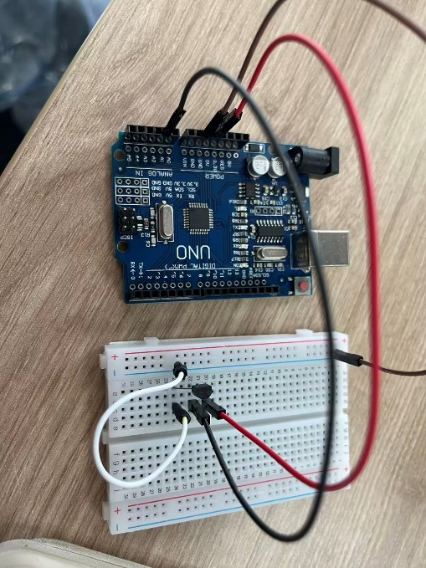
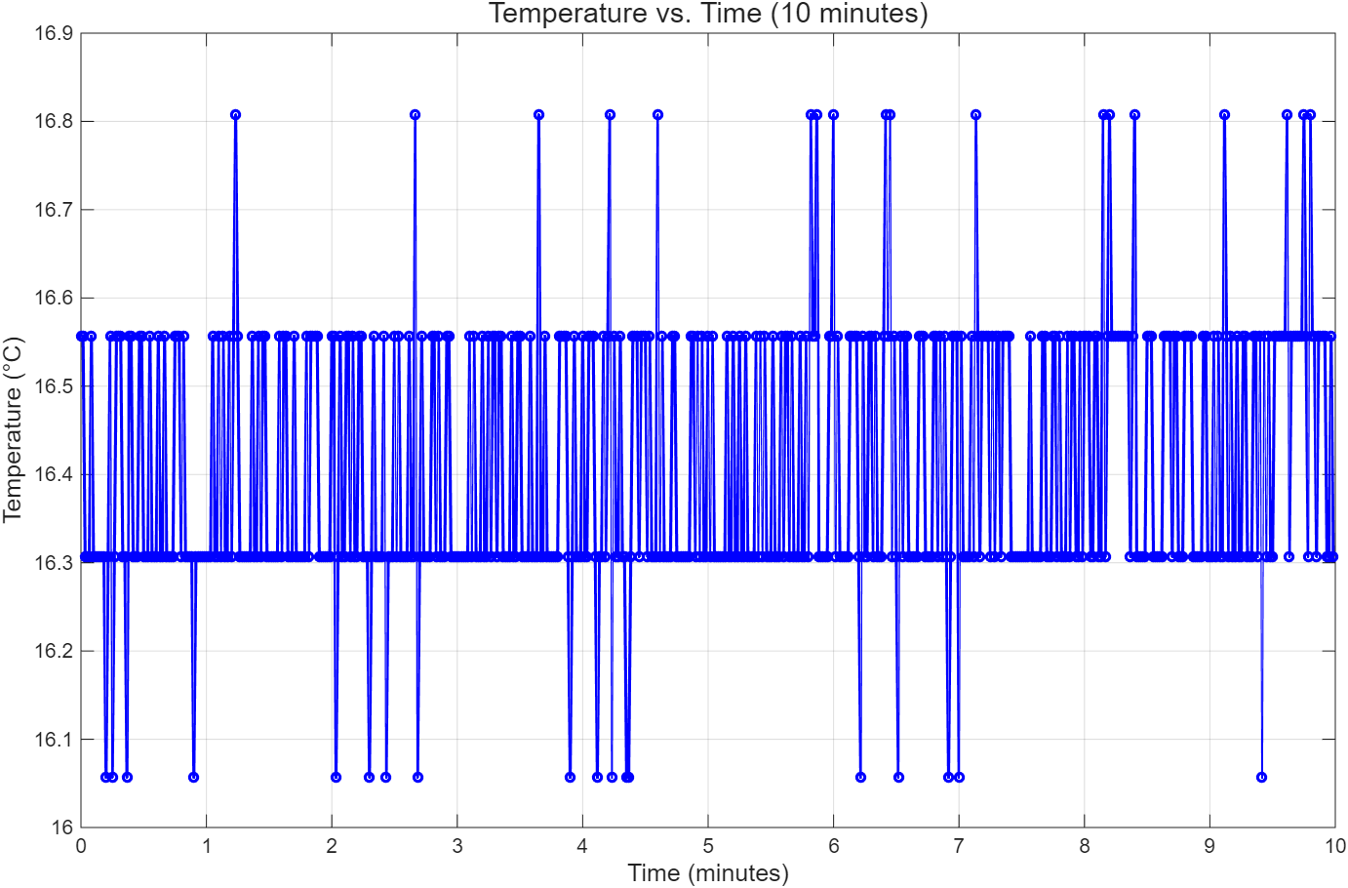
Answer:
Data logging initiated - 13/03/2026
Location - Nottingham
Minute 0
Temperature 16.56 C
Minute 1
Temperature 16.31 C
Minute 2
Temperature 16.56 C
Minute 3
Temperature 16.31 C
Minute 4
Temperature 16.56 C
Minute 5
Temperature 16.56 C
Minute 6
Temperature 16.81 C
Minute 7
Temperature 16.06 C
Minute 8
Temperature 16.56 C
Minute 9
Temperature 16.31 C
Minute 10
Temperature 16.31 C
Max temp 16.81 C
Min temp 16.06 C
Average temp 16.41 C
Data logging terminated

TASK 2 – LED TEMPERATURE MONITORING DEVICE IMPLEMENTATION [25 MARKS]
Main
clear; clc; close all;

% Hardware configuration - Arduino & pin definitions
arduino_port = 'COM3'; % Arduino serial port
arduino_board = 'Uno'; % Arduino board model
pin_green = 'D2'; % Green LED digital pin (18-24°C range)
pin_yellow = 'D3'; % Yellow LED digital pin (<18°C)
pin_red = 'D4'; % Red LED digital pin (>24°C)
sensor_pin = 'A1'; % Temperature sensor analog pin

% MCP9700A sensor calibration parameters
V0C = 0.4; % Voltage at 0°C (V)
Tc = 0.01953; % Temperature coefficient (V/°C)
monitor_duration = 600; % Monitoring duration (10 mins = 600s)

% Clear existing Arduino connection to avoid conflict
if exist('a', 'var')
clear a;
disp(' The old Arduino connection has been cleared. ');
end

% Establish Arduino communication (critical for hardware control)
try
a = arduino(arduino_port, arduino_board); % Create Arduino communication object
disp(' The Arduino connection was successful!');
catch ME
error('Arduino connection failed.');
end

disp([' Start the temperature monitoring system... (Duration: ', num2str(monitor_duration/60), 'min)']);

% Execute temperature prediction function (Task 3 core logic)
try
temp_prediction(a, pin_green, pin_yellow, pin_red, sensor_pin, V0C, Tc, monitor_duration);
catch ME
disp([' Monitoring interrupted/error: ', ME.message]);
end

% Cleanup - turn off all LEDs and release Arduino connection
if exist('a', 'var')
writeDigitalPin(a, pin_green, 0); % Set pin to low (turn off LED)
writeDigitalPin(a, pin_yellow, 0);
writeDigitalPin(a, pin_red, 0);
clear a;
disp(' Resource cleanup completed! ');
else
disp(' There is no valid Arduino connection. No need to clean ');
end

function temp_monitor
function temp_monitor(a, pin_green, pin_yellow, pin_red, sensor_pin, V0C, Tc, duration)

configurePin(a, pin_green, 'digitaloutput'); % Set green LED pin as digital output
configurePin(a, pin_yellow, 'digitaloutput'); % Set yellow LED pin as digital output
configurePin(a, pin_red, 'digitaloutput'); % Set red LED pin as digital output

% Initialize all LEDs to off (low level)
writeDigitalPin(a, pin_green, 0);
writeDigitalPin(a, pin_yellow, 0);
writeDigitalPin(a, pin_red, 0);

% Create real-time plot window
figure('Color','w', 'Position', [100, 100, 800, 500]);
h_plot = plot(0, 0, 'b-o', 'LineWidth', 1.5, 'MarkerSize', 4);
xlabel('Time (s)', 'FontSize', 12);
ylabel('Temperature (°C)', 'FontSize', 12);
title(['Real-time Temperature Monitoring (MCP9700A) - ', num2str(duration/60), 'minute'], 'FontSize', 14);
grid on;
xlim([0, duration]);
ylim([0, 40]);
legend('Temperature', 'Location', 'best');
time_list = []; % Store time data for plot
temp_list = []; % Store temperature data for plot
start_time = tic; % Start timing

while true
V_out = readVoltage(a, sensor_pin); % Read sensor output voltage (A1 pin)
temp = (V_out - V0C) / Tc; % Convert voltage to temperature (MCP9700A formula)
current_time = toc(start_time); % Get elapsed time
time_list = [time_list, current_time];
temp_list = [temp_list, temp];

% Update real-time plot data and refresh
set(h_plot, 'XData', time_list, 'YData', temp_list);
xlim([0, max(current_time, duration)]);
ylim([min(temp_list)-2, max(temp_list)+2]);
drawnow;

% LED control logic based on temperature range
if temp >= 18 && temp <= 24
writeDigitalPin(a, pin_green, 1); % Green LED on (comfort range: 18-24°C)
writeDigitalPin(a, pin_yellow, 0);
writeDigitalPin(a, pin_red, 0);
pause(1);

elseif temp < 18
writeDigitalPin(a, pin_green, 0);
writeDigitalPin(a, pin_red, 0);

writeDigitalPin(a, pin_yellow, 1); % Yellow LED blink (0.5s on/off)
pause(0.5);
writeDigitalPin(a, pin_yellow, 0);
pause(0.5);

else
writeDigitalPin(a, pin_green, 0);
writeDigitalPin(a, pin_yellow, 0);

writeDigitalPin(a, pin_red, 1); % Red LED blink (0.25s on/off)
pause(0.25);
writeDigitalPin(a, pin_red, 0);
pause(0.25);
end

% Stop monitoring when reaching set duration
if current_time >= duration
disp([' The monitoring duration has reached（', num2str(duration/60), 'minutes）,Stop automatically. ']);
break;
end
fprintf(' %.1fs | temperature: %.2f ℃\n', current_time, temp);
end
% Turn off all LEDs after monitoring ends
writeDigitalPin(a, pin_green, 0);
writeDigitalPin(a, pin_yellow, 0);
writeDigitalPin(a, pin_red, 0);
disp('All leds have been turned off and the monitoring has ended normally!');
end
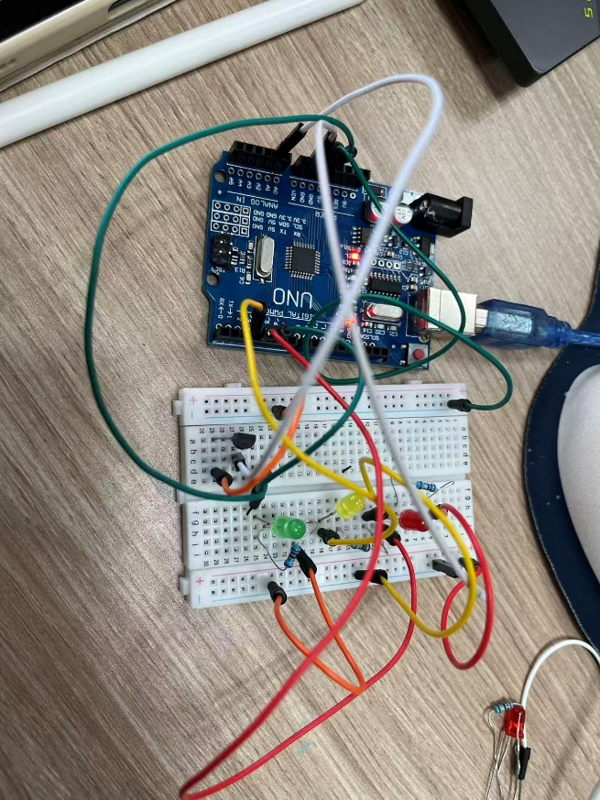
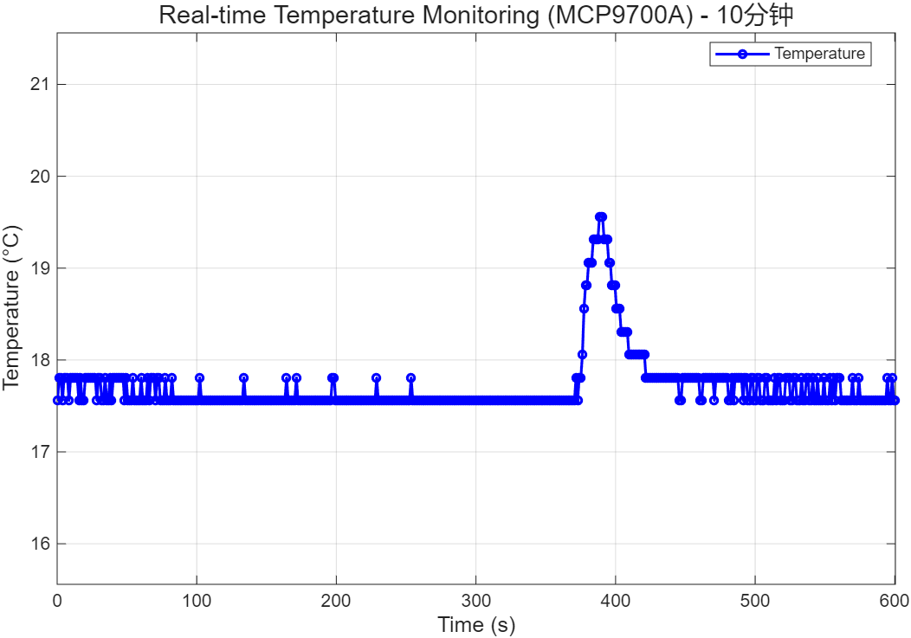
Touch the sensor
Stop touching
TASK 3 – ALGORITHMS – TEMPERATURE PREDICTION [ 30 MARKS]
Main
clear; clc; close all;
arduino_port = 'COM3';
arduino_board = 'Uno';
pin_green = 'D2';
pin_yellow = 'D3';
pin_red = 'D4';
sensor_pin = 'A1';
V0C = 0.4;
Tc = 0.01953;
monitor_duration = 600
if exist('a', 'var')
clear a;
disp(' The old Arduino connection has been cleared. ');
end
try
a = arduino(arduino_port, arduino_board);
disp(' The Arduino connection was successful!');
catch ME
error('Arduino connection failed.');
end

disp([' Start the temperature monitoring system... (Duration: ', num2str(monitor_duration/60), 'min)']);
try
temp_prediction(a, pin_green, pin_yellow, pin_red, sensor_pin, V0C, Tc, monitor_duration);
catch ME
disp([' Monitoring interrupted/error: ', ME.message]);
end
if exist('a', 'var')
writeDigitalPin(a, pin_green, 0);
writeDigitalPin(a, pin_yellow, 0);
writeDigitalPin(a, pin_red, 0);
clear a;
disp(' Resource cleanup completed! ');
else
disp(' There is no valid Arduino connection. No need to clean ');
end

function temp_ prediction
function [time_data, temp_data, rate_data, predict_data] = temp_prediction(a, pin_green, pin_yellow, pin_red, sensor_pin, V0C, Tc, duration)
configurePin(a, pin_green, 'digitaloutput'); % Set green LED pin as digital output
configurePin(a, pin_yellow, 'digitaloutput'); % Set yellow LED pin as digital output
configurePin(a, pin_red, 'digitaloutput'); % Set red LED pin as digital output

% Initialize all LEDs to off (low level)
writeDigitalPin(a, pin_green, 0);
writeDigitalPin(a, pin_yellow, 0);
writeDigitalPin(a, pin_red, 0);

window_size = 5; % Sliding window size for noise reduction (5 samples)
temp_history = [];
time_history = [];
start_time = tic; % Start timing

% Initialize output arrays to store monitoring data
time_data = [];
temp_data = [];
rate_data = [];
predict_data = [];

% Create dual-subplot window for temp & change rate
figure('Color','w', 'Position', [100, 100, 800, 600]);
subplot(2,1,1);
h_temp = plot(0, 0, 'b-o', 'LineWidth', 1.5, 'MarkerSize', 4);
xlabel('Time (s)', 'FontSize', 12);
ylabel('Temperature (°C)', 'FontSize', 12);
title('Real-time Temperature & Change Rate (MCP9700A)', 'FontSize', 14);
grid on;
xlim([0, duration]);
ylim([0, 40]);
legend('Temperature', 'Location', 'best');

subplot(2,1,2);
h_rate = plot(0, 0, 'r-*', 'LineWidth', 1.5, 'MarkerSize', 4);
xlabel('Time (s)', 'FontSize', 12);
ylabel('Change Rate (°C/min)', 'FontSize', 12);
grid on;
xlim([0, duration]);
ylim([-10, 10]);
legend('Change Rate', 'Location', 'best');

while true
V_out = readVoltage(a, sensor_pin); % Read sensor voltage (A1 pin)
current_temp = (V_out - V0C) / Tc; % Convert voltage to temperature (MCP9700A formula)
current_time = toc(start_time); % Get elapsed time

% Update sliding window (keep latest N samples for noise reduction)
temp_history = [temp_history, current_temp];
time_history = [time_history, current_time];
if length(temp_history) > window_size
temp_history(1) = [];
time_history(1) = [];
end

% Calculate temperature change rate (°C/s → °C/min)
if length(temp_history) >= 2
delta_T = temp_history(end) - temp_history(1);
delta_t = time_history(end) - time_history(1);
rate_Cs = delta_T / delta_t; % Change rate (°C/s)
rate_Cmin = rate_Cs * 60; % Convert to °C/min
else
rate_Cs = 0;
rate_Cmin = 0;
end
predict_temp = current_temp + rate_Cs * 300; % Predict temp in 5 mins (300s)

% Update data arrays
time_data = [time_data, current_time];
temp_data = [temp_data, current_temp];
rate_data = [rate_data, rate_Cmin];
predict_data = [predict_data, predict_temp];

% LED alert logic based on change rate (threshold: ±4°C/min)
if rate_Cmin > 4
writeDigitalPin(a, pin_green, 0);
writeDigitalPin(a, pin_yellow, 0);
writeDigitalPin(a, pin_red, 1); % Red LED on (temp rising too fast)
elseif rate_Cmin < -4
writeDigitalPin(a, pin_green, 0);
writeDigitalPin(a, pin_yellow, 1); % Yellow LED on (temp dropping too fast)
writeDigitalPin(a, pin_red, 0);
else
writeDigitalPin(a, pin_green, 1); % Green LED on (stable temp)
writeDigitalPin(a, pin_yellow, 0);
writeDigitalPin(a, pin_red, 0);
end

% Update real-time plots
set(h_temp, 'XData', time_data, 'YData', temp_data);
xlim(h_temp.Parent, [0, max(current_time, duration)]);
ylim(h_temp.Parent, [min(temp_data)-2, max(temp_data)+2]);
set(h_rate, 'XData', time_data, 'YData', rate_data);
xlim(h_rate.Parent, [0, max(current_time, duration)]);
drawnow;

% Print real-time data to console
fprintf(' %.1fs | Now：%.2f ℃ | rate of change：%.2f ℃/min | 5min Forecast：%.2f ℃\n', ...
current_time, current_temp, rate_Cmin, predict_temp);

% Stop loop when reaching set duration
if current_time >= duration
disp([' The monitoring duration has reached(', num2str(duration/60), 'min), automatic stop']);
break;
end

pause(1); % 1s sampling interval
end

% Turn off all LEDs after monitoring
writeDigitalPin(a, pin_green, 0);
writeDigitalPin(a, pin_yellow, 0);
writeDigitalPin(a, pin_red, 0);
disp(' All leds have been turned off and the monitoring has ended normally！');
disp(' Real-time data has been retained and can be viewed through the output parameters');
disp(' - time_data：Sampling time (seconds)');
disp(' - temp_data：Real-time temperature (℃)');
disp(' - rate_data：Real-time rate of change (℃/min)');
disp(' - predict_data：5-minute predicted temperature (℃)');

end
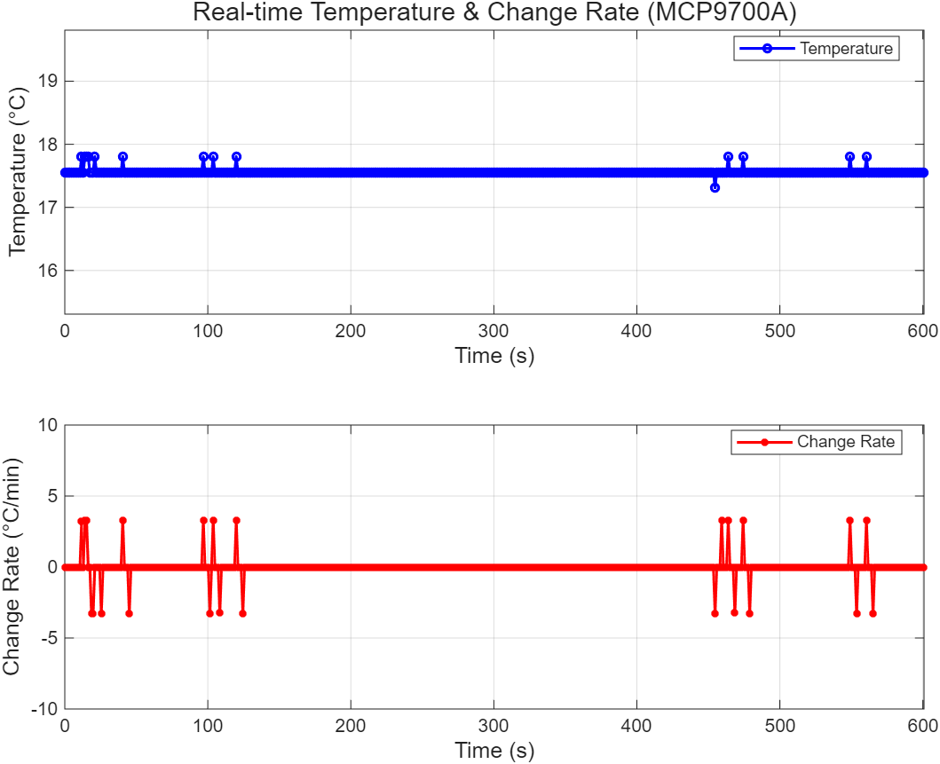
Answer (1 minute):
0.2s | Now：17.56 ℃ | rate of change：0.00 ℃/min | 5min Forecast：17.56 ℃
1.4s | Now：17.56 ℃ | rate of change：0.00 ℃/min | 5min Forecast：17.56 ℃
2.5s | Now：17.56 ℃ | rate of change：0.00 ℃/min | 5min Forecast：17.56 ℃
3.7s | Now：17.56 ℃ | rate of change：0.00 ℃/min | 5min Forecast：17.56 ℃
4.8s | Now：17.56 ℃ | rate of change：0.00 ℃/min | 5min Forecast：17.56 ℃
6.0s | Now：17.56 ℃ | rate of change：0.00 ℃/min | 5min Forecast：17.56 ℃
7.1s | Now：17.56 ℃ | rate of change：0.00 ℃/min | 5min Forecast：17.56 ℃
8.3s | Now：17.56 ℃ | rate of change：0.00 ℃/min | 5min Forecast：17.56 ℃
9.5s | Now：17.56 ℃ | rate of change：0.00 ℃/min | 5min Forecast：17.56 ℃
10.6s | Now：17.56 ℃ | rate of change：0.00 ℃/min | 5min Forecast：17.56 ℃
11.8s | Now：17.81 ℃ | rate of change：3.24 ℃/min | 5min Forecast：34.00 ℃
12.9s | Now：17.56 ℃ | rate of change：0.00 ℃/min | 5min Forecast：17.56 ℃
14.1s | Now：17.81 ℃ | rate of change：3.26 ℃/min | 5min Forecast：34.08 ℃
15.2s | Now：17.81 ℃ | rate of change：3.26 ℃/min | 5min Forecast：34.12 ℃
16.4s | Now：17.81 ℃ | rate of change：0.00 ℃/min | 5min Forecast：17.81 ℃
17.5s | Now：17.56 ℃ | rate of change：0.00 ℃/min | 5min Forecast：17.56 ℃
18.7s | Now：17.56 ℃ | rate of change：-3.27 ℃/min | 5min Forecast：1.22 ℃
19.8s | Now：17.56 ℃ | rate of change：-3.27 ℃/min | 5min Forecast：1.23 ℃
21.0s | Now：17.81 ℃ | rate of change：0.00 ℃/min | 5min Forecast：17.81 ℃
22.1s | Now：17.56 ℃ | rate of change：0.00 ℃/min | 5min Forecast：17.56 ℃
23.3s | Now：17.56 ℃ | rate of change：0.00 ℃/min | 5min Forecast：17.56 ℃
24.4s | Now：17.56 ℃ | rate of change：0.00 ℃/min | 5min Forecast：17.56 ℃
25.6s | Now：17.56 ℃ | rate of change：-3.29 ℃/min | 5min Forecast：1.12 ℃
26.7s | Now：17.56 ℃ | rate of change：0.00 ℃/min | 5min Forecast：17.56 ℃
27.9s | Now：17.56 ℃ | rate of change：0.00 ℃/min | 5min Forecast：17.56 ℃
29.0s | Now：17.56 ℃ | rate of change：0.00 ℃/min | 5min Forecast：17.56 ℃
30.2s | Now：17.56 ℃ | rate of change：0.00 ℃/min | 5min Forecast：17.56 ℃
31.3s | Now：17.56 ℃ | rate of change：0.00 ℃/min | 5min Forecast：17.56 ℃
32.5s | Now：17.56 ℃ | rate of change：0.00 ℃/min | 5min Forecast：17.56 ℃
33.6s | Now：17.56 ℃ | rate of change：0.00 ℃/min | 5min Forecast：17.56 ℃
34.8s | Now：17.56 ℃ | rate of change：0.00 ℃/min | 5min Forecast：17.56 ℃
35.9s | Now：17.56 ℃ | rate of change：0.00 ℃/min | 5min Forecast：17.56 ℃
37.1s | Now：17.56 ℃ | rate of change：0.00 ℃/min | 5min Forecast：17.56 ℃
38.2s | Now：17.56 ℃ | rate of change：0.00 ℃/min | 5min Forecast：17.56 ℃
39.4s | Now：17.56 ℃ | rate of change：0.00 ℃/min | 5min Forecast：17.56 ℃
40.5s | Now：17.81 ℃ | rate of change：3.26 ℃/min | 5min Forecast：34.09 ℃
41.7s | Now：17.56 ℃ | rate of change：0.00 ℃/min | 5min Forecast：17.56 ℃
42.8s | Now：17.56 ℃ | rate of change：0.00 ℃/min | 5min Forecast：17.56 ℃
44.0s | Now：17.56 ℃ | rate of change：0.00 ℃/min | 5min Forecast：17.56 ℃
45.1s | Now：17.56 ℃ | rate of change：-3.28 ℃/min | 5min Forecast：1.18 ℃
46.3s | Now：17.56 ℃ | rate of change：0.00 ℃/min | 5min Forecast：17.56 ℃
47.4s | Now：17.56 ℃ | rate of change：0.00 ℃/min | 5min Forecast：17.56 ℃
48.6s | Now：17.56 ℃ | rate of change：0.00 ℃/min | 5min Forecast：17.56 ℃
49.7s | Now：17.56 ℃ | rate of change：0.00 ℃/min | 5min Forecast：17.56 ℃
50.9s | Now：17.56 ℃ | rate of change：0.00 ℃/min | 5min Forecast：17.56 ℃
52.0s | Now：17.56 ℃ | rate of change：0.00 ℃/min | 5min Forecast：17.56 ℃
53.2s | Now：17.56 ℃ | rate of change：0.00 ℃/min | 5min Forecast：17.56 ℃
54.3s | Now：17.56 ℃ | rate of change：0.00 ℃/min | 5min Forecast：17.56 ℃
55.5s | Now：17.56 ℃ | rate of change：0.00 ℃/min | 5min Forecast：17.56 ℃
56.6s | Now：17.56 ℃ | rate of change：0.00 ℃/min | 5min Forecast：17.56 ℃
57.8s | Now：17.56 ℃ | rate of change：0.00 ℃/min | 5min Forecast：17.56 ℃
58.9s | Now：17.56 ℃ | rate of change：0.00 ℃/min | 5min Forecast：17.56 ℃
60.1s | Now：17.56 ℃ | rate of change：0.00 ℃/min | 5min Forecast：17.56 ℃

